**Go to search:**

**Click on Keyword.**

**Select barcode**

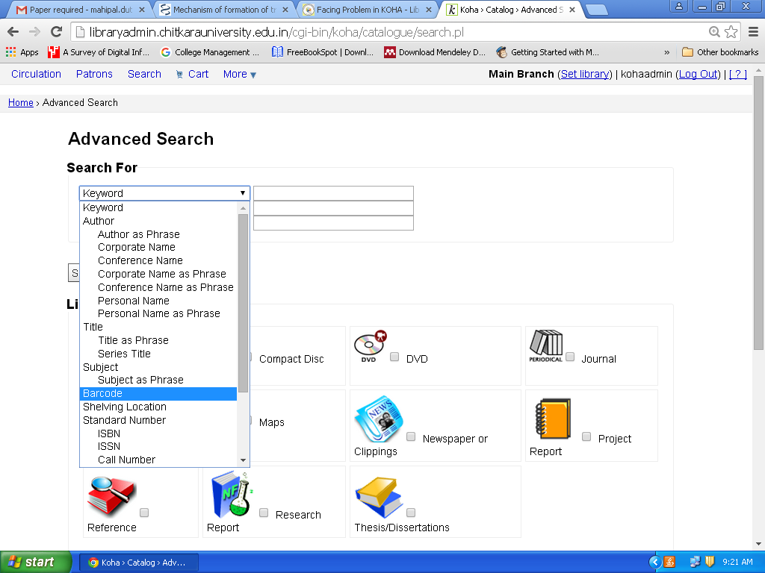

**Enter desired barcode**

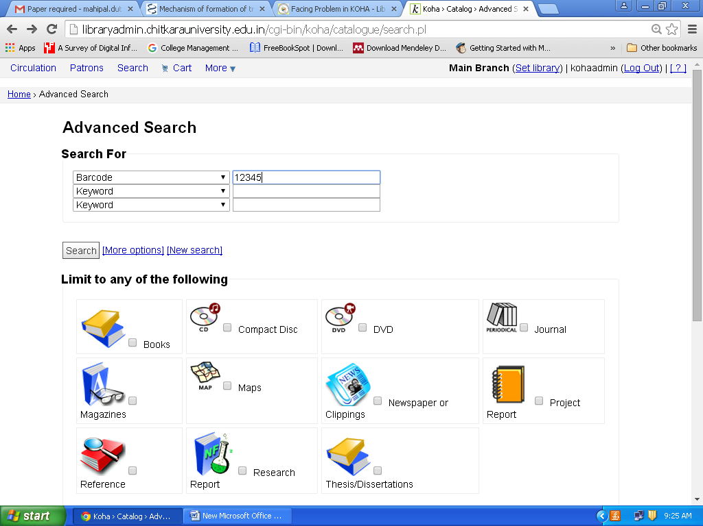

**It will show only the desired barcode information.**

